PRACTICAL QUESTIONS FOR DATA VISUALISATION AND ANALYTICS (CIA1C11)
Practical 1 – Introduction to Data Analytics / Getting the Required Software

This practical aims to introduce students to the data-driven decision approach and orientate students to the KNIME desktop and how it can be used to support the CRISP-DM approach to data analytics.

Question 1 (Case Study on Data Literacy)
- Form a group of 4 to 6 members. Explore the dashboards by going to this website - https://demos.qlik.com/qliksense/CampaignforDataLiteracy Click on Launch Demo. This may take a little while.

Once the demo is launched, you will see a selection of dashboards which present the findings of a Data Literacy Survey. Select the dashboard on “Demographics”.

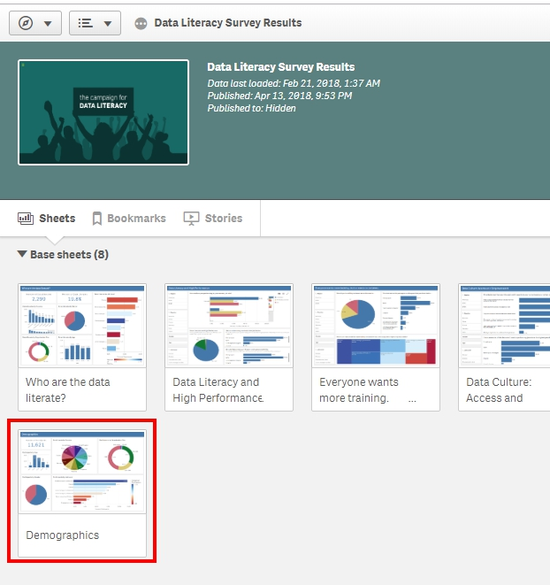

Answer the following questions:

  - How many individuals were surveyed?
Ans:

  - Which country was best represented in the survey (most respondents from the country)?
Ans:

  - Which age-group of respondents have the highest number of respondents?
Ans:

  - How many respondents belongs to organizations with > 500 workers?
Ans:

At the top right corner of your screen, click on the sheet selector and select the “Data Literacy and High Performance” sheet.


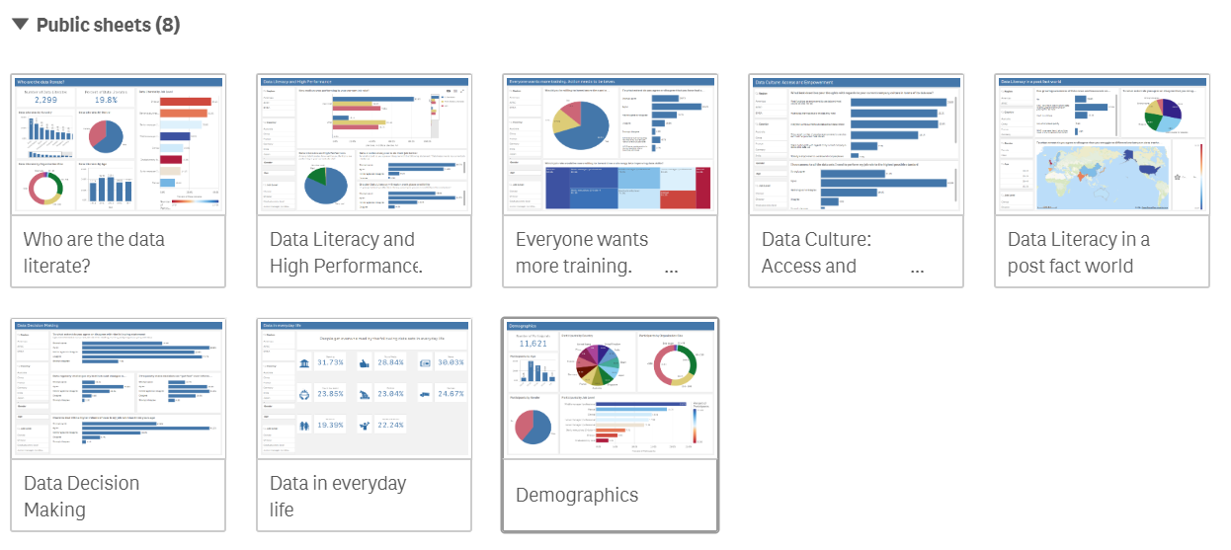

Answer the following questions:

  - What percentage of Manual workers Strongly Agrees with the statement “Data enables everyone to do their job better”?
Ans:

  - Among respondents from Singapore, what percentage of respondents who are data literate feel that they are performing very well in their current job role?
Ans:

- Form a group of 4 to 6 members. Think about your own diploma of study, discuss how data analytics can be adopted in your field of study.

Dip | How Data Analytics can be adopted
IT | Resource allocation for project, Forecast equipment failures, asset availability, production costs and maintenance costs.  http://www.informit.com/articles/article.aspx?p=2461067&seqNum=3  How predictive analytics will disrupt software development  https://techbeacon.com/predictive-analytics-disrupt-software-development
CDF | Monitor malware spread, monitor CPU, memory, disk I/O to determine cyber attack  https://learn.techbeacon.com/units/introduction-cyber-security-threat-detection-analytics  Challenges to Cyber Security & How Big Data Analytics Can Help  https://www.datameer.com/blog/challenges-to-cyber-security-and-how-big-data-analytics-can-help/
FBI | Fraud Detection  https://www.bit.com.au/news/credit-card-fraud-patterns-revealed-482144  Data Analytics in the Financial Services Industry  https://www.pwc.com/id/en/publications/Actuarial/data-analytics-financial-services.pdf
AAI, BDA and Common ICT | Inform students that Data Analytics is cross domain, get them to provide you with some examples.  https://www.simplilearn.com/tutorials/big-data-tutorial/big-data-applications  https://dataconomy.com/2021/01/ai-in-analytics-powering-the-future-of-data-analytics/
GDD | Gameplay data for game behaviour analytics, recommender systems, data-driven commentary  https://andersdrachen.com/2017/08/09/the-case-for-data-in-esports/  How big data is disrupting the gaming industry  https://www.cio.com/article/3251172/big-data/how-big-data-is-disrupting-the-gaming-industry.html


- Take the Data Literacy Assessment https://thedataliteracyproject.org/

What is your Data Personality?
Data Aristocrat / Data Knight / Data Dreamer / Data Doubter

- Complete this All-About-You survey to get to know your cohort of students better. Click on link or scan QR code.

https://tinyurl.com/erybue56

Question 2 (Download and Install KNIME Analytics Platform)
1. Before downloading Power BI, you need to find out if your computer is 32-bit or 64-bit.

How do you tell? Click on your document folder

Right-click on This PC Select Properties Look for System Type Note whether your computer is 32-bit or 64-bit.
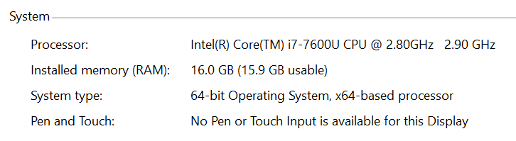

2. Instructions to install KNIME Analytics Platform
Go to https://www.knime.com/knime
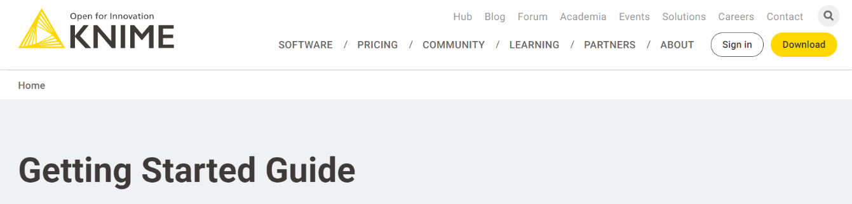
Click the “Download” link.

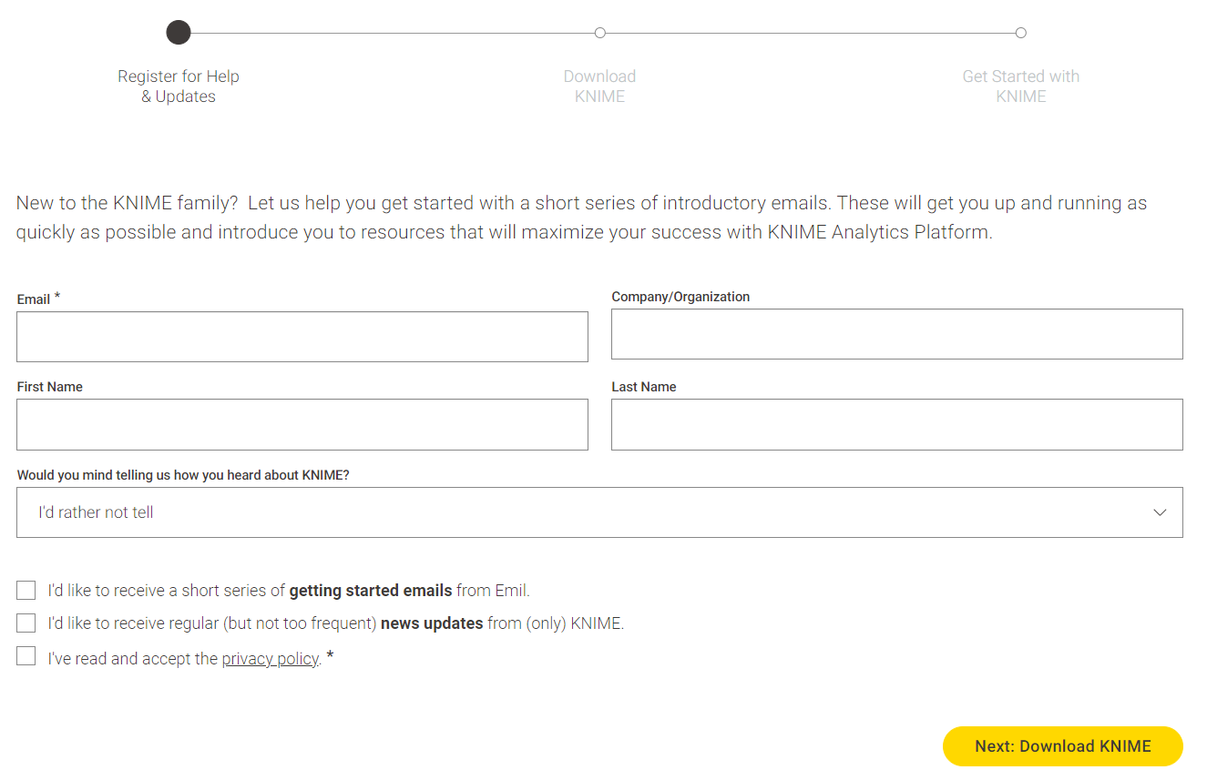
You will see a 3 Step installation process.
Register using your email address, accept the privacy policy, and click Next: Download KNIME.
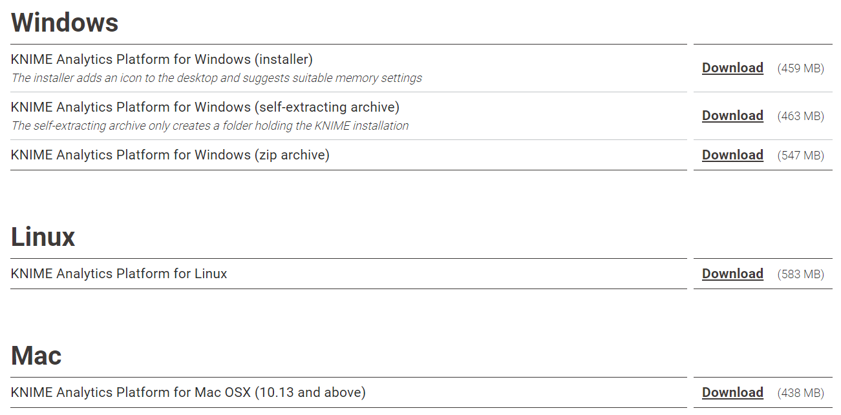
Depending on your machine setting, select the appropriate installer to download.

3. Some helpful links:
- Watch this video on installing KNIME https://youtu.be/8ISIeFKkoOE
- Additional readings on installation https://www.knime.com/installation-0

Question 3 (Download and Install Power BI)
1. Go to https://powerbi.microsoft.com/en-us/downloads/ Look for Microsoft Power BI Desktop Click on Advanced download options
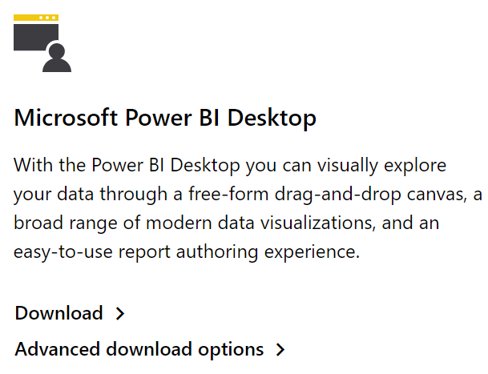

You will enter the Download Centre Scroll down to Microsoft Power BI Click Download.
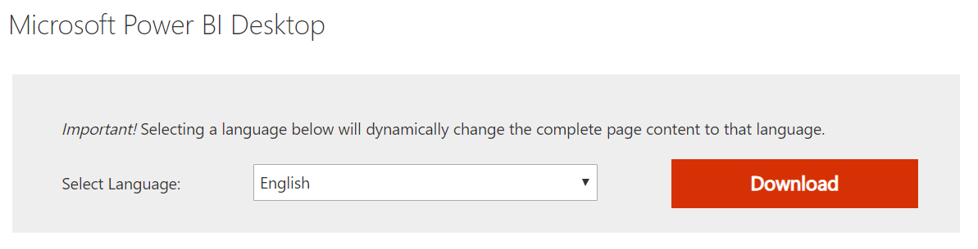

If your computer is 64-bit, put a check on PBIDesktopSetup_x64.exe.
If your computer is 32-bit, put a check on PBIDesktopSetup.exe.

Click Next The .exe file will be downloaded (see the left bottom corner of your screen).
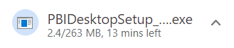

Once it is fully downloaded Click on the .exe file installation process will begin.

For Mac Users

Option 1 : : Use Power BI Service
Sign in to Power BI Service in the cloud (URL : https://powerbi.microsoft.com/en-us/) using your TP student email account. You should be able to most of the exercises for visualisation in this course. However, there are some functionalities that are available to Power BI Desktop, but are not available in Power BI Service.

Option 2 : Power BI Desktop that is accessible via TP WVD
Alternatively, login to TP Window Virtual Desktop using your TP student email account. Then click on DAVA Desktop to access Power BI Desktop.

2. Some helpful links:
- Getting started with Power BI desktop https://docs.microsoft.com/en-us/power-bi/desktop-getting-started
- Learning Power BI https://docs.microsoft.com/en-us/power-bi/guided-learning/

Question 4 (Download Dataset)
1. Go to https://lms.tp.edu.sg/ Select CIA1C11 Data Visualisation and Analytics Look for Lessons Tab Click DAVA Dataset Hover over DAVA Dataset.zip Right-click Select Save Link As Save the compressed zip file to your downloads folder.
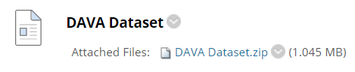

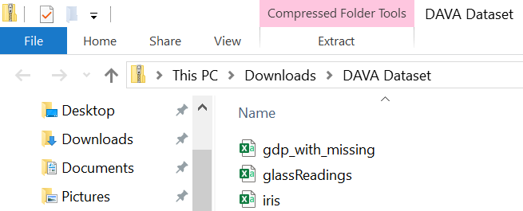
2. You will be directed automatically to your Downloads Folder and see what is inside the zip file.

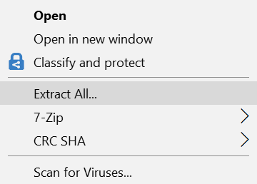
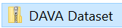
Click on the up-arrow Look for DAVA Dataset.zip Right-click Extract All

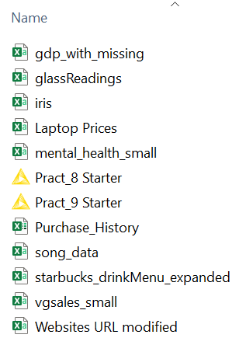
Browse to your desired destination folder Click Extract. You will see all the data files needed for this course.


3. Continue to do the same and save all Practical sheets and E-Lecture slides to your local drive.
– End of Practical 1 –

